 | Project funded by the European Commission under the 6th (EC) RTD  Framework Programme (2002- 2006) within the framework of the specific research and technological development programme “Integrating and strengthening the European Research Area” | 
Project UpWind  Contract No.:  019945 (SES6) | “Integrated Wind Turbine Design”



Damage growth in glass fiber reinforced polymer (GFRP) composite under tension-tension fatigue loads

Author: | Hongwei ZHOU
Affiliation: | China University of Mining and Technology (Beijing)
Address: | Xueyuan Road D11, Beijing 100083, P. R. China
Tel.: | +86 10 62331286
Email: | zhw@cumtb.edu.cn
Further Authors: | L. Mishnaevsky Jr., P. Brøndsted, L. L. Gui, H. L. Yan
Reviewer:
Approver:

Document Information
Document Type
Document Name: | Damage growth in glass fiber reinforced polymer (GFRP) composite under tension-tension fatigue loads
Revision:
Rev.Date:
Classification: | R1: Restricted to project members
Status:

Contents

1. Contents 3
2. Tension-tension fatigue test of GFRP 3
2.1 Materials and dimensions of specimens 3
2.2 Fatigue test parameters 4
3. Process and analyze the fatigue data 4
3.1 S-N curves of specimen at different orientation angels of fibers 5
3.2 Elastic modulus 6
3.3 Energy dissipation 6
3.4 Damage growth 7
3.5 Fatigue crack 9
4. Conclusions 10

Status, Confidentiality and Accessibility
Status |  |  |  | Confidentiality |  |  |  | Accessibility
S0 | Approved/Released |  |  | R0 | General public |  |  | Private web site
S1 | Reviewed |  |  | R1 | Restricted to project members | R1 |  | Public web site
S2 | Pending for review |  |  | R2 | Restricted to European. Commission |  |  | Paper copy
S3 | Draft for commends |  |  | R3 | Restricted to WP members + PL
S4 | Under preparation |  |  | R4 | Restricted to Task members +WPL+PL

PL: Project leader | WPL: Work package leader | TL: Task leader

Damage growth in glass fiber reinforced polymer (GFRP) composite under tension-tension fatigue loads

1. Contents

(1) Considering the effects of orientation angles of fibers on fatigue life of GFRP, tension-tension fatigue tests are carried out by means of the fatigue test system with Scanning Electron Microscopy (SEM).
(2) The elastic modulus E is determined at different orientation angels of fibers with respect to applied load. And the fatigue damage is characterized by changes of elastic modulus.
(3) The development of fatigue cracks as well as the main fatigue damage forms at different angels is characterized on the basis of SEM images.

2. Tension-tension fatigue test of GFRP

2.1 Materials and dimensions of specimens
All the GFRP composite specimens were prepared by water jet technology. In order to investigate the influence of fiber orientation angles on the mechanical behavior of composite materials, the fibers are arranged at different orientation angles with respect to horizontal direction such as 0⁰, 15⁰, 30⁰, 45⁰, 60⁰, 75⁰, and 90⁰, respectively (Figure 1). The dimensions and identification numbers of specimens are shown in Table 1.

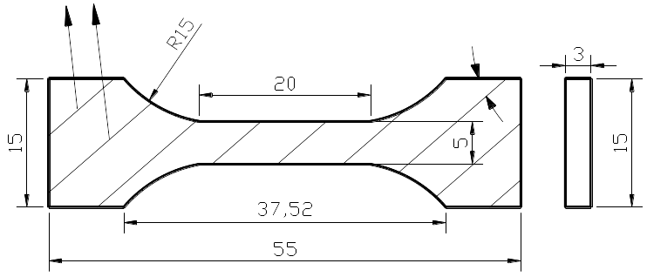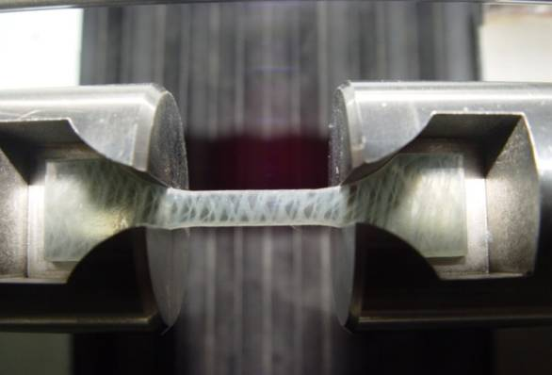
fibers
angels
(a) Specimen (b) Loading
Figure 1 Dimensions of specimens for tension-tension fatigue tests (unit: mm).

Table 1 Identification numbers of specimen for faigue test and their scales (unit: mm)
Specimen ID | L | H | W | A（mm²） | Specimen view
UT-F-0°-1 | 20 | 4.52 | 3.04 | 13.7408
UT-F-15°-1 | 20 | 5.18 | 2.90 | 15.022
UT-F-30°-1 | 20 | 5.10 | 2.94 | 14.994
UT-F-45°-1 | 20 | 5.10 | 2.96 | 15.096
UT-F-60°-1/2 | 20 | 5.40/5.20 | 2.94/3.00 | 15.876/15.6
UT-F-75°-1/2 | 20 | 5.02/5.00 | 2.96/2.82 | 14.859/14.1
UT-F-90°-1/2 /3/4/5 | 20 | 4.98/5.2/5.16/4.86/4.70 | 0.3/2.92/2.98/3.02/3.04 | 14.94/15.184/15.377/14.68/14.288
Note: The identification number of specimens was defined as UT-F-m⁰-n, where U means uniaxial, T means tension, F means fatigue, m means orientation angles of fibers with respect to horizontal direction, and n means the group number of specimens.

2.2 Fatigue test parameters
(1) Loading form: constant amplitude stress (triangle wave);
(2) Loading amplitude: 0.2-0.6KN (in elastic range);
(3) Temperature: room temperature;
(4) Data acquisition: acquire data at the 100th cycle at the first time, and acquire data every 2000 cycles later, i.e., at the interval of 2000 cycles;
(5) Loading frequency: 10Hz.
The tests are carried out with constant loading amplitude of 0.2-0.6KN, which are determined by the static tension test data, ensuring that the stress falls in the elastic range. The stress of specimen under load can be estimated by:
$σ=\frac{P}{A}$ (1)
where $σ$ is the normal stress of specimen, P is the load applied on specimen, A is the sectional area of specimen (Table 2).

Table 2 Stress of specimen under peak load
Specimen ID | A(mm2) | $σ_{\text{min}}$(MPa) | $σ_{\text{max}}$(MPa)
UT-F-0°-1 | 13.7408 | 14.5552 | 43.6656
UT-F-15°-1 | 15.0220 | 13.3138 | 39.9414
UT-F-30°-1 | 14.9940 | 13.3387 | 40.0160
UT-F-45°-1 | 15.0960 | 13.2485 | 39.7456
UT-F-60°-1 | 15.8760 | 12.5976 | 37.7929
UT-F-60°-2 | 15.6000 | 12.8205 | 38.4615
UT-F-75°-1 | 14.8592 | 13.4596 | 40.3790
UT-F-75°-2 | 14.1000 | 14.1844 | 42.5532
UT-F-90°-5 | 14.2800 | 13.9977 | 41.9933

3. Process and analyze the fatigue data

According to the data of static tension tests, the peak loads on specimen with angels of θ =0°, 15°, 30°, 45°, 60°,75°,90° are 3.8KN, 2.2KN, 1.05KN, 0.57KN, 0.6KN, 0.88KN, 0.8KN respectively. So the loading amplitudes are taken 0.2-0.6KN (Figure 2). Stress ratio can be obtained by
$R=\frac{σ_{\text{min}}}{σ_{\text{max}}}$ (2)
where $σ_{\text{min}}$ and $σ_{\text{max}}$ are the minimum and maximum stresses (here R=1/3).
Figure 2 Fatigue load vs cycle number curve

3.1 S-N curves of specimen at different orientation angels of fibers
The test data are automatically recorded by test system, and the S-N curves of specimen at different orientation angels of fibers are shown in Figure 3.

(a) θ=0° (b) θ=15°

(c) θ=30° (d) θ=45°
(i) θ=75° (k) θ=90°
Figure 3 S-N curves at different orientation angels.

3.2 Elastic modulus
According to the secant of unloading curve (Figure 4), the longitudinal elastic modulus E can be estimated by
$E=\frac{\text{Pl}}{AΔl}$ (3)
where P is the load applied on specimen, l is the efficient loading length of specimen, A is the sectional area, Δl is the displacement measured by test machine.

Figure 4 Typical load-displacement curve in a cycle.

The slope of secant line can be estimated by
$P\text{\sim }\text{kS}$ (4)
where k is the slope of secant line, S is the displacement. Substitute Eq(4) into Eq (3), the longitudinal elastic modulus E can be estimated by
$E=k\frac{l}{A}$ (5)

3.3 Energy dissipation
According to load-displacement curve (Figure 5) in a cycle, the dissipated energy, i.e., the area between the loading and unloading curves, can be calculated by
(6)
where f₁ means loading curve, f₂ means unloading curve, a is the minimum displacement, and b is the maximum displacement.

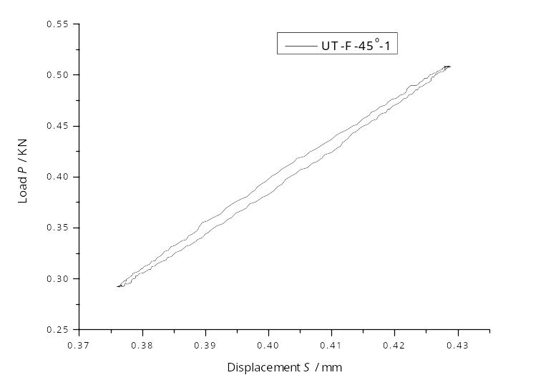
f₁
f₂
Figure 5 Typical load-displacement curve in a cycle.

3.4 Damage growth
Elastic modulus and energy dissipation of specimens at different cycle number and orientation angels can be calculated (Figure 6). It indicates that the elastic modulus present a linear reduction tendency with the sampling number.
Cycle number N
Energy dissipation
(a) Elastic modulus (θ=0°) (b) Energy dissipation (θ=0°)

Cycle number N
Energy dissipation
(c) Elastic modulus (θ=15°) (d) Energy dissipation (θ=15°)
Cycle number N
Energy dissipation
(e) Elastic modulus (θ=30°) (f) Energy dissipation (θ=30°)

Cycle number N
Energy dissipation
(g) Elastic modulus (θ=45°) (h) Energy dissipation (θ=45°)

Cycle number N
Energy dissipation
(i) Elastic modulus (θ=75°) (j) Energy dissipation (θ=75°)
Cycle number N
Energy dissipation
(k) Elastic modulus (θ=90°) (l) Energy dissipation (θ=90°)
Figure 6 Damage characterization of specimen at different orientation angels.
(Note: cycle number=1000+(sampling numer-1)×2000)

3.5 Fatigue crack
During loading, real-time SEM images showing the changes in a meso-scale structure of GFRP composite are taken, as shown in Figure 7.

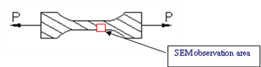
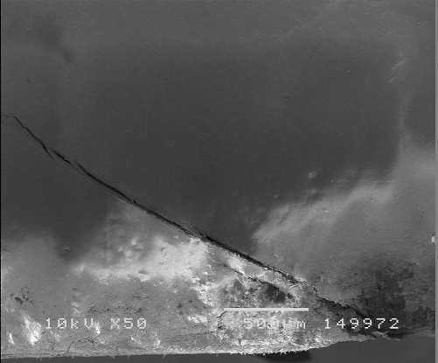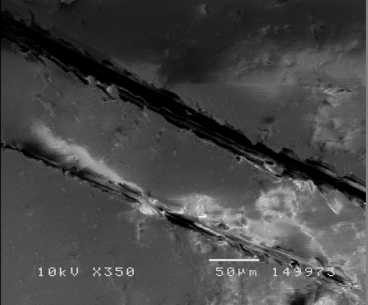
(a) SEM images at the 1530000th cycle (b) SEM images at the 1531200th cycle
Figure 7 SEM images of specimen No. UT-F-30°-1.

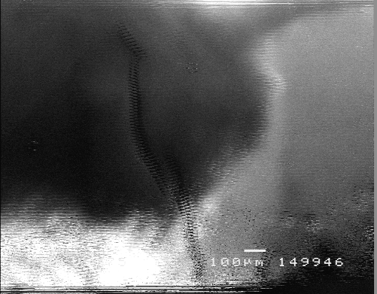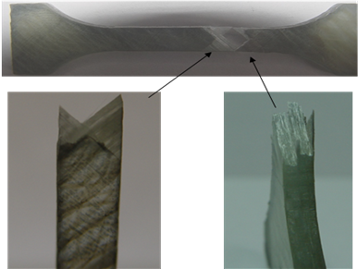
(b) The cross-section of specimen after fracture and the lamination
(a) Fatigue crack evolution at the 1800th cycle before fracture

Figure 8 SEM images of specimen No. UT-F-45°-1.

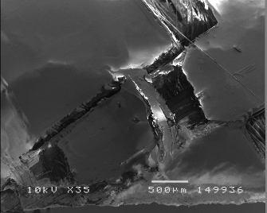
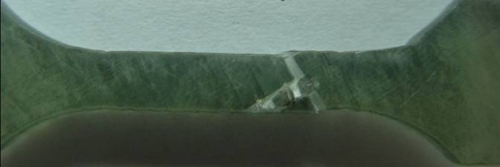
(a) The main crack is in accordance with fibers after fracture
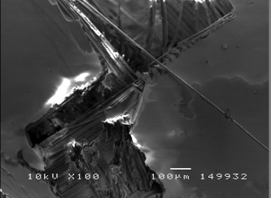

(b) The lamination on specimen edge

Figure 9 SEM images of specimen No. UT-F-60°-2

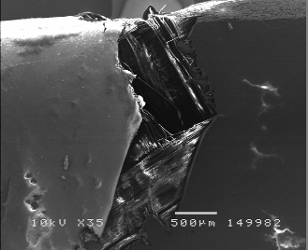
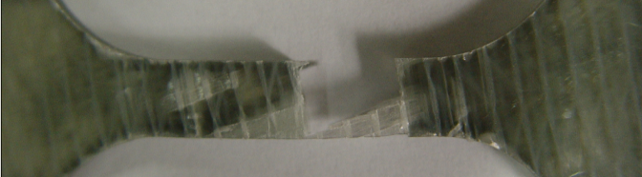
(a) The main crack extend along 75°direction

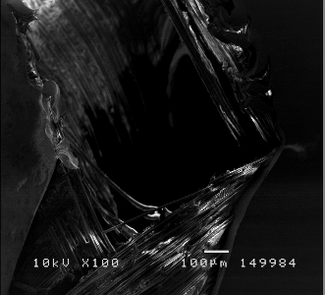
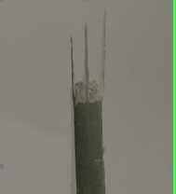
(b) Lamination
Figure 10 SEM images of specimen No. UT-F-75°-1.

4. Conclusions

(1) The elastic modulus are related to the orientation angels of fibers with respect to loading direction, i.e., they decrease with the increase of the orientation angels.
(2) The energy dissipation is related to the orientation angels of fibers under the same cycle number of fatigue loading.
(3) The main cracks develop mostly along the interface between main fibers and matrix.

